**Lab 7: Writing Queries with LINQ**

**Code:**

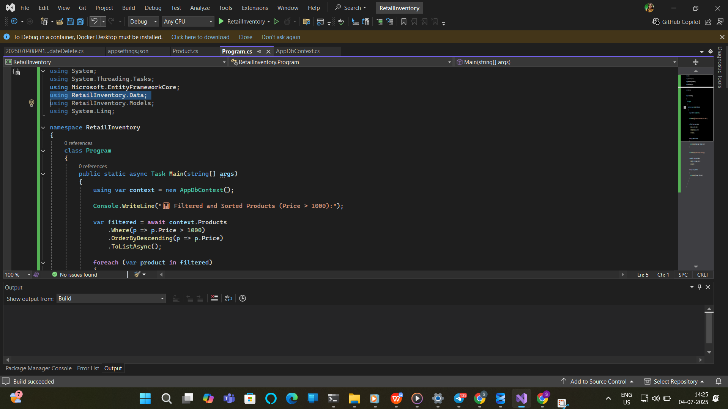

**Output:**

